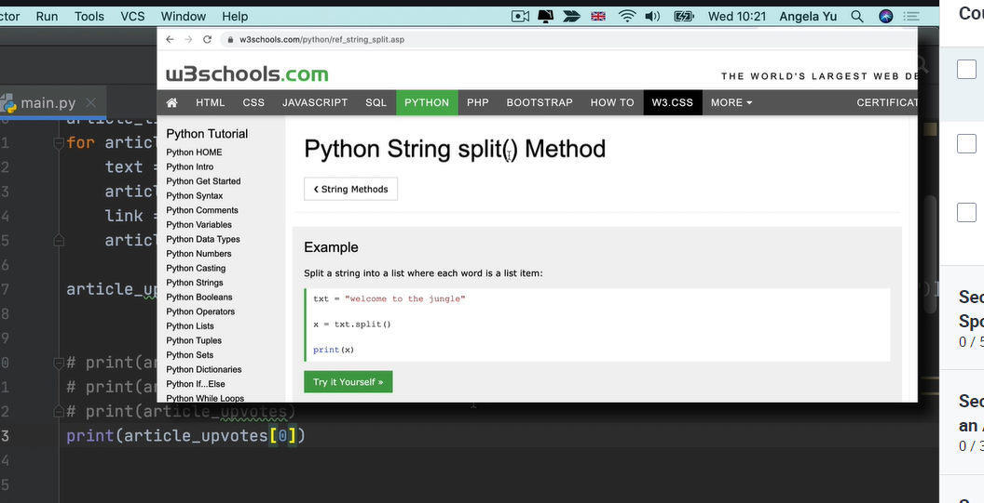Day 41 HTML CSS and Web Foundation from Angelas Web dev bootcamp

Can use Python for web dev too

Code Pen

<https://codepen.io/>

DevDocs API Documentation

<https://devdocs.io/>

MDM docs about html

<https://developer.mozilla.org/en-US/docs/Web/HTML/Element/Heading_Elements>

w3schools html

<https://www.w3schools.com/html/html_headings.asp>

Gutenberg Library Adventures of sherlock Homes

<https://www.gutenberg.org/ebooks/1661>

Internet Archive way back machine

<https://archive.org/web/>

List of UTF-8 characters

<https://www.fileformat.info/info/charset/UTF-8/list.htm>

Joel Spolsky Unicode character Sets

<https://www.joelonsoftware.com/2003/10/08/the-absolute-minimum-every-software-developer-absolutely-positively-must-know-about-unicode-and-character-sets-no-excuses/>

Unicode character table

<https://unicode-table.com/en/>

